Neshaminy School District
2001 Old Lincoln Highway • Langhorne, Pennsylvania 19047-3295

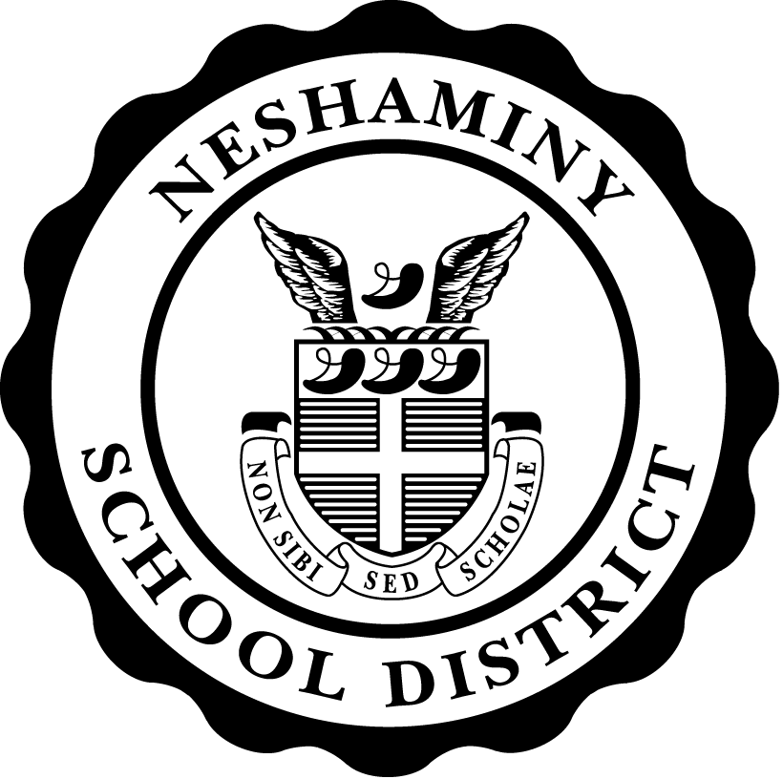
Mr. Joseph Jones
Superintendent of Schools
Field Trip Form
Parent/Guardian Permission
 |  |  | has my permission to travel to
student name
New Amsterdam Theatre, Broadway, NY | by | BUS |  | on | May 3, 2017
trip destination |  | bus, train, car, etc. |  |  | date

Emergency Information
Parent/Guardian can be reached at the following telephone numbers all day on the day of the trip.
mother’s home, work or cell number |  | father’s home, work or cell number
In the event no one is available at the above listed numbers, please contact:
name/relationship to child |  | home/cell number
My child has the following allergies/medical condition the staff needs to be made aware of:

Emergency Medication to be carried by student on the trip
(Asthma Multi-Dose Inhaler or Epi-Pen)
Medication Name: |  |  |  |  | Dosage:
Time: |  |  | Special Instructions:

Students on Daily Medication
Please indicate below regarding your child’s daily medicine dose for the day of the field trip:
My child may omit his/her dose for the day of the trip. *Must have a doctor’s note.
My child may take the dose when he/she returns to school.

I have completed the above permission for my child’s participation in this school trip. In the event of an emergency, I give permission for my child to be taken to the nearest hospital for emergency treatment.

Parent/Guardian Signature
T:\ Devlin/Share Point Forms\Field Trip Form

